SQL ASSIGNMENT – 3

Department Table :

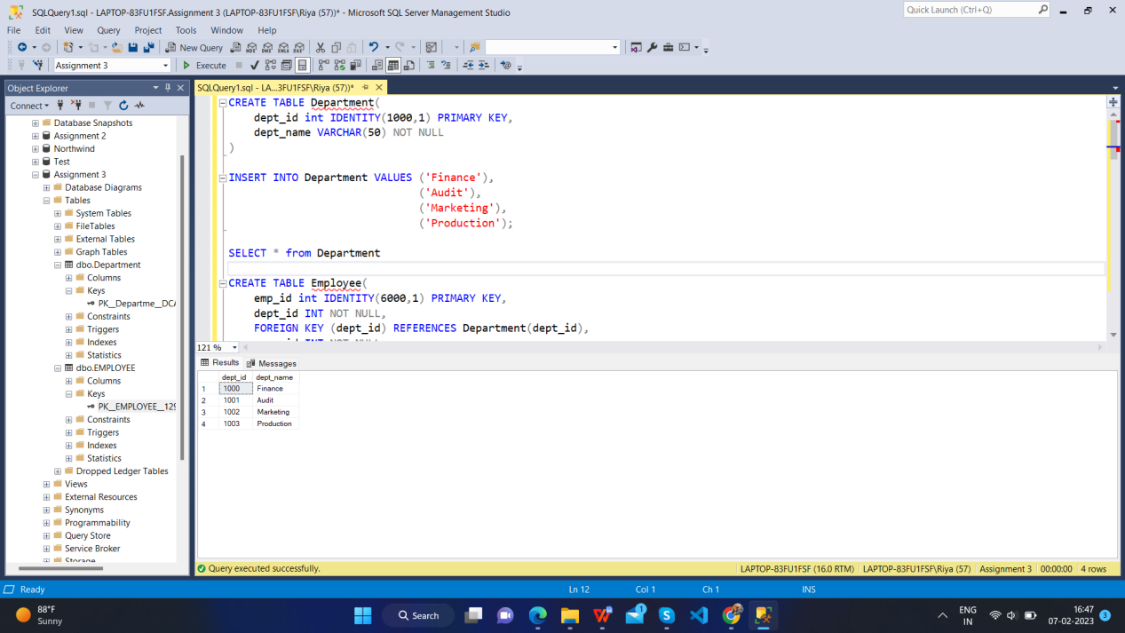

Employee Table :

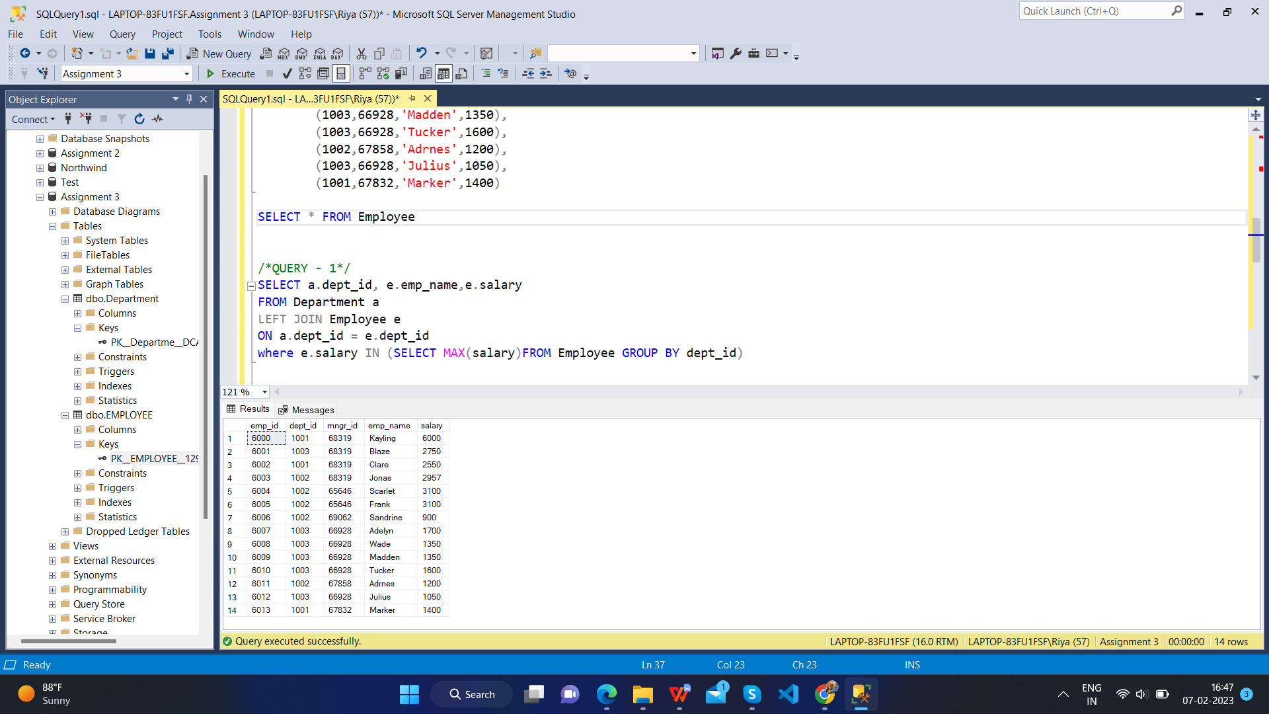

/*QUERY - 1*/

SELECT a.dept_id, e.emp_name,e.salary

FROM Department a

LEFT JOIN Employee e

ON a.dept_id = e.dept_id

where e.salary IN (SELECT MAX(salary)FROM Employee GROUP BY dept_id)

OUTPUT -

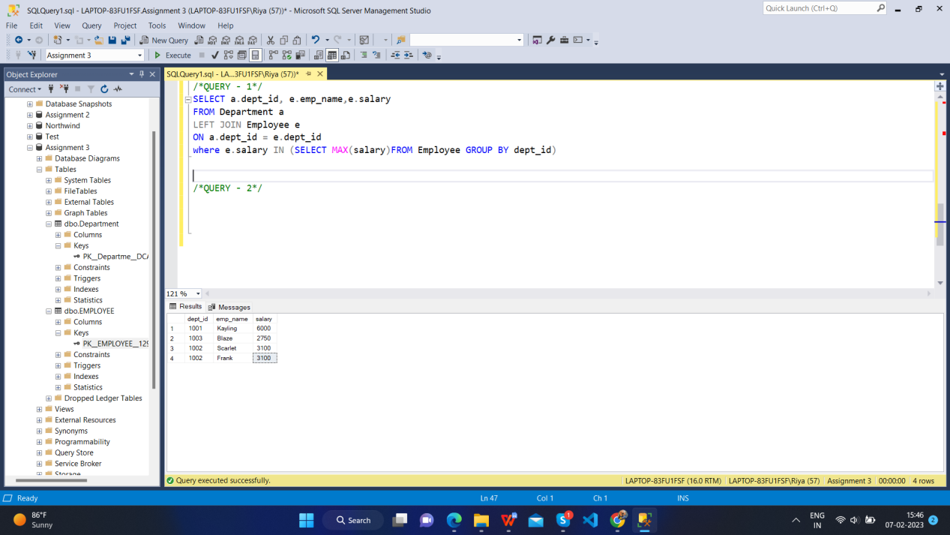

/*QUERY - 2*/

SELECT d.dept_name

FROM Department d

INNER JOIN Employee e

ON d.dept_id = e.dept_id

GROUP BY d.dept_name

HAVING COUNT(*) <= 3;

OUTPUT -

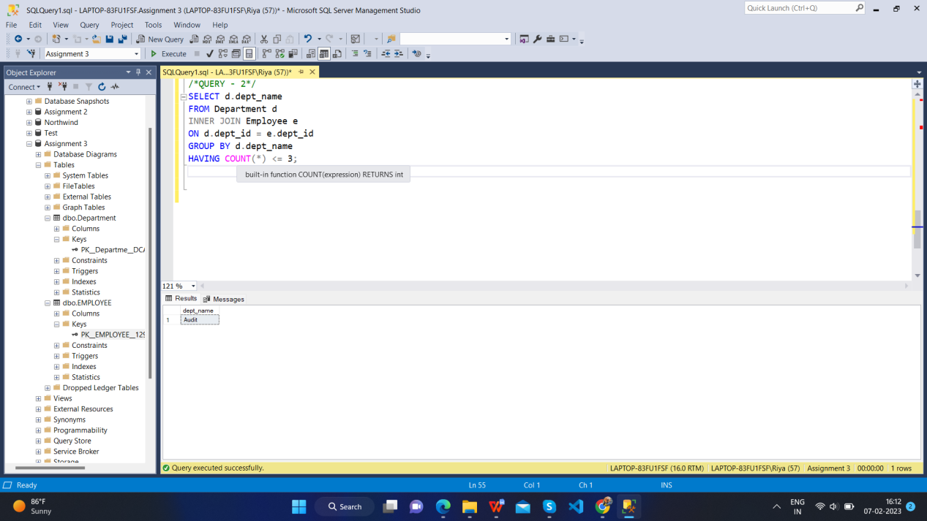

/*QUERY - 3*/

SELECT d.dept_name, count(e.emp_name) AS NumberOfEmployee

FROM Department d

LEFT JOIN Employee e

ON d.dept_id = e.dept_id

GROUP BY d.dept_name

OUTPUT -

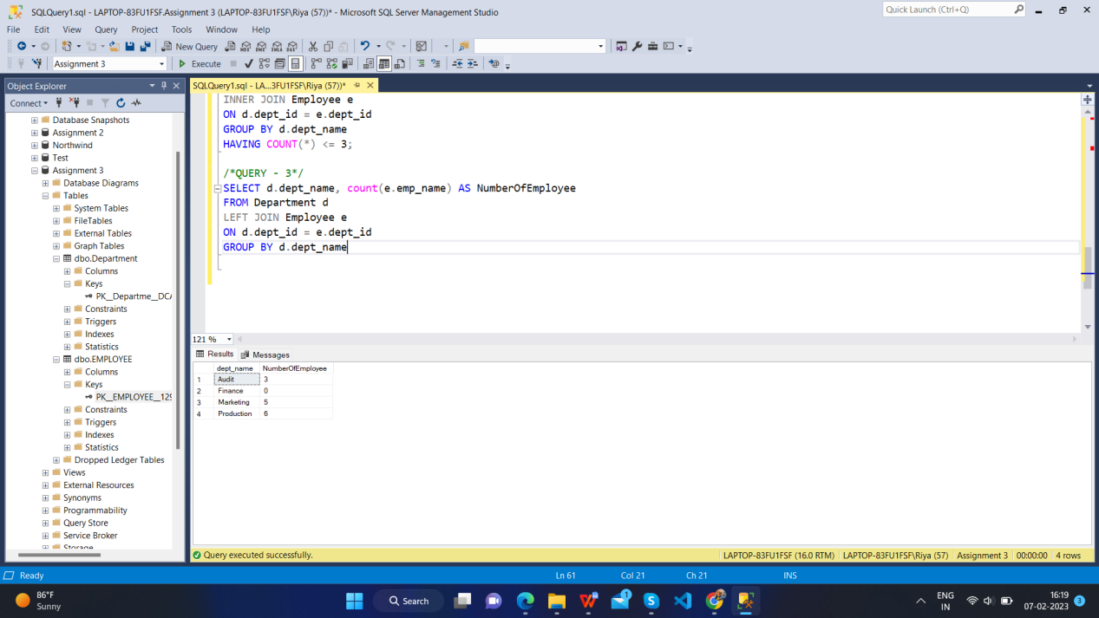

/*QUERY - 4*/

SELECT d.dept_name, sum(e.salary) AS TotalSalary

FROM Department d

LEFT JOIN Employee e

ON d.dept_id = e.dept_id

GROUP BY d.dept_name

OUTPUT -

